KUTU’S
DOCUMENTATION FOR WATER BOTTLE TRY HACK CHALLENGE
OBJECTIVE:
Finding information using nothing from scratch with things from the man lost brain memory and OSINT.
TOOL: The internet
Process:
- I open my browser and loggin to my Try Hack Me website…mind you I already have an account signed up already…
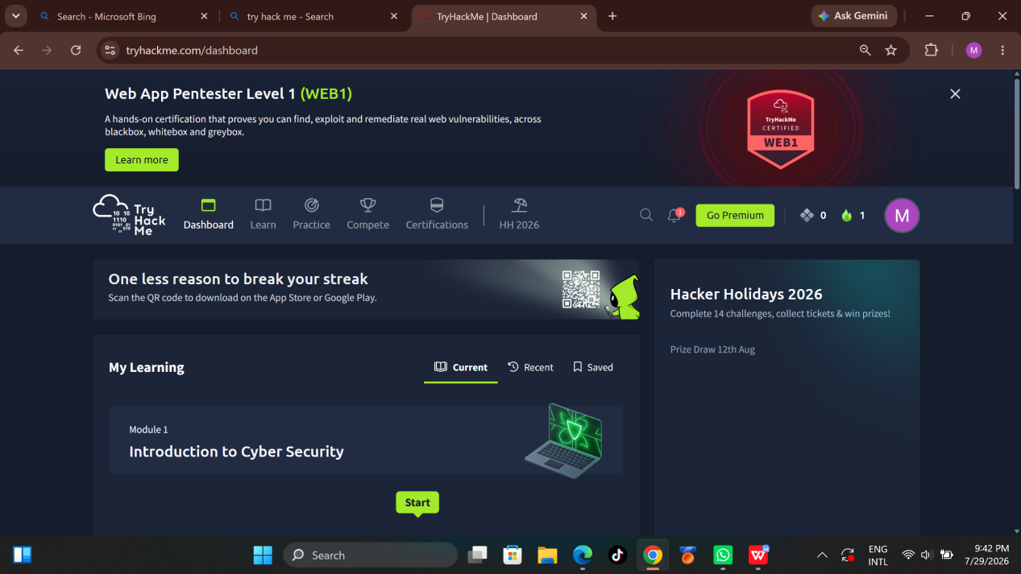
- So I search for the water bottle challenge in the search bar showed in the pic below
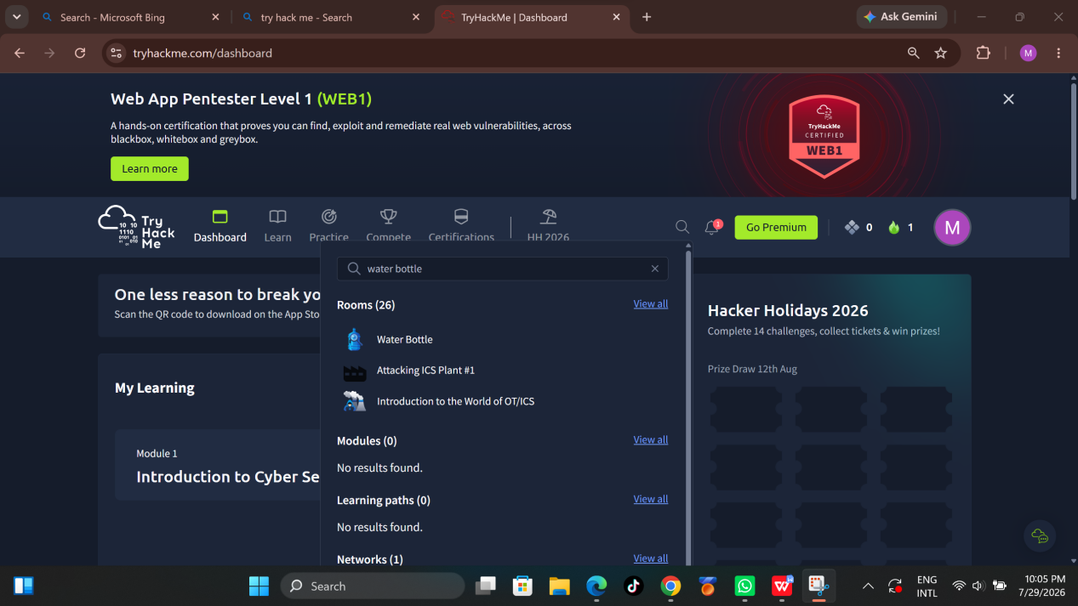
- After joining the water bottle Room, I read the instructions and proceed with the challenge…
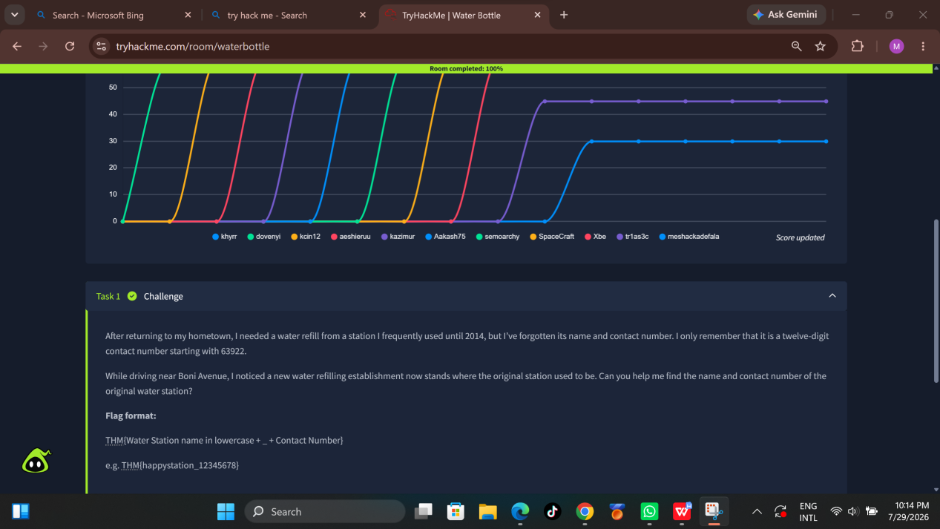
- First I went ahead to google maps website to find water filling stations near boni avenue road.
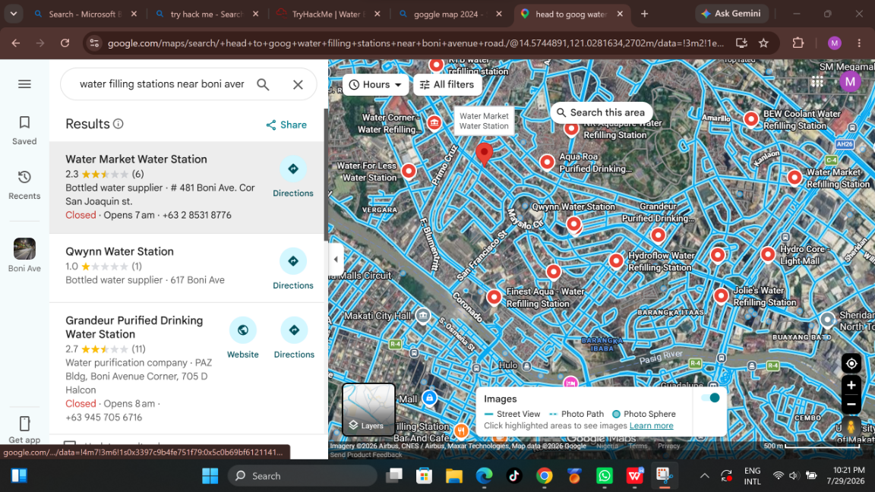
- I searched each and every water filling stations, going back in time in 2014 in each filling stations then I discovered in 2014 AquaBest Water Station was in position of Alkafresco Water Refilling Station of today 2026.
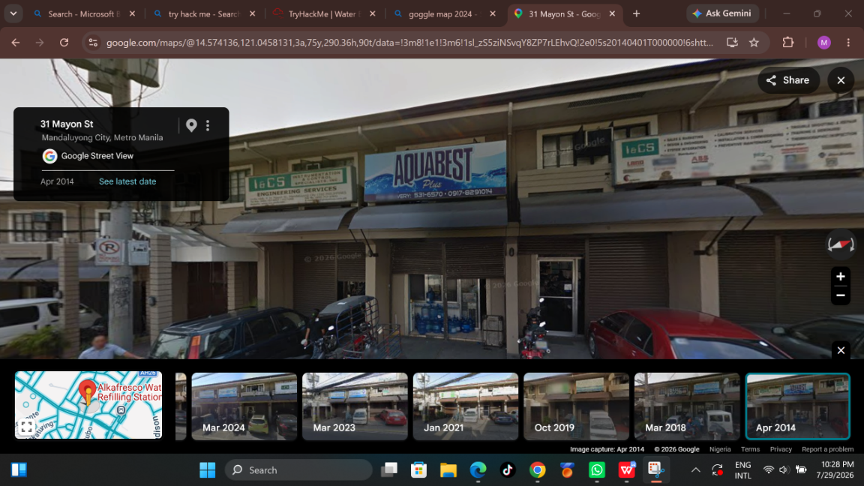
Other Water Refilling Stations didn’t yield good results so that’s why they I didn’t include their screenshot here, IN ORDER TO SAVE TIME AND SPACE….
- Then I searched on Aquabest Mandaluyong water filling station on a new tab on my browser.
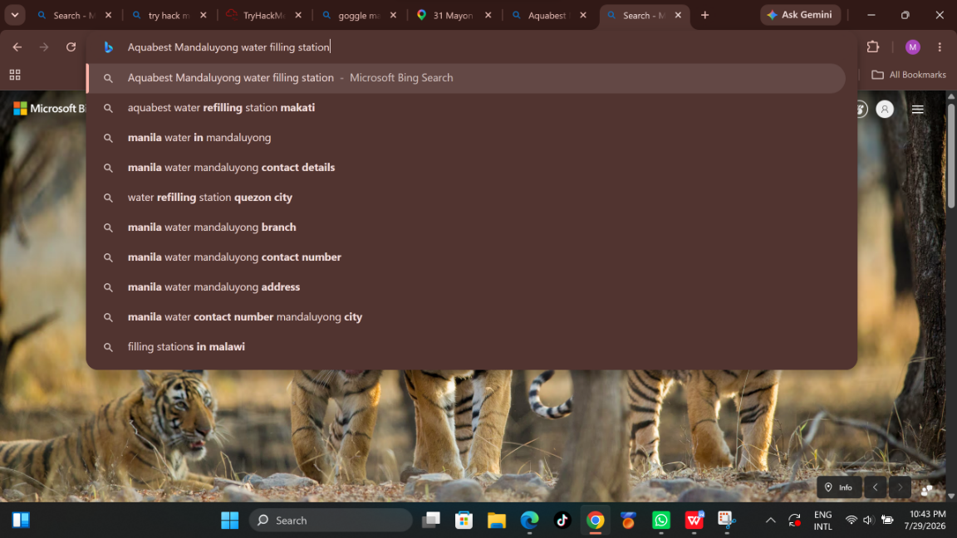

- I finally then found a contact page for the Aquabest Mandaluyong water filling station, As Highlighted below in the picture.
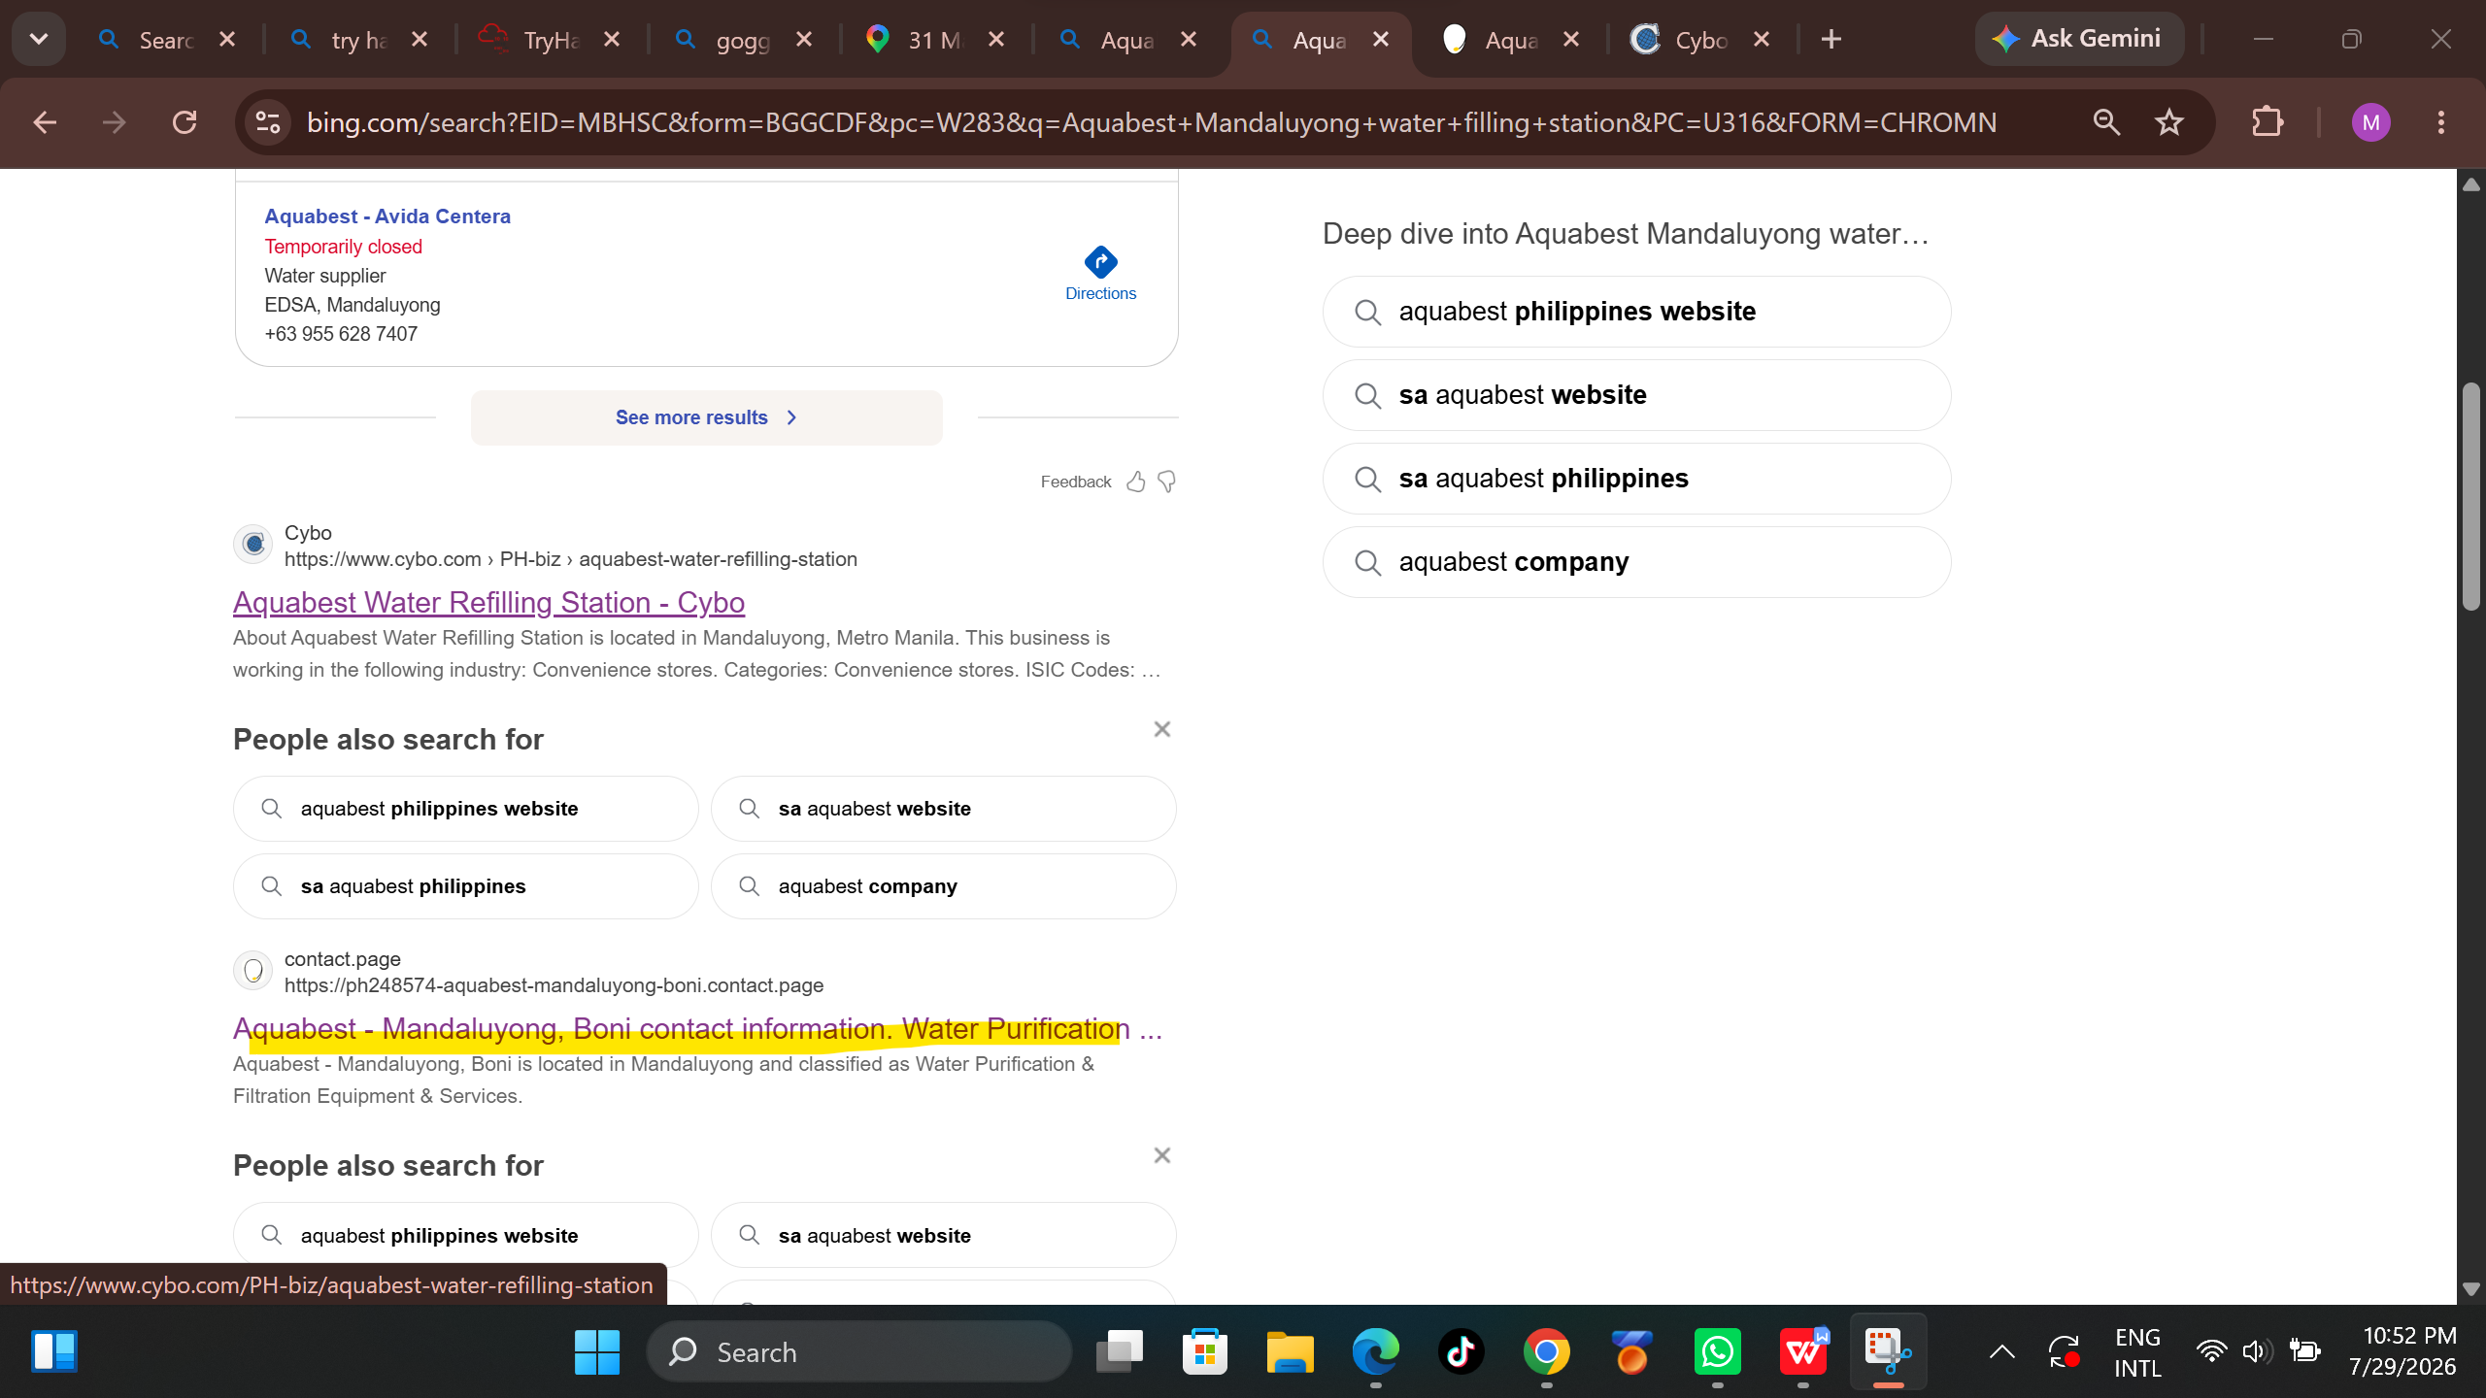
- After clicking the link I then discovered and found the contact information of the company referred from the challenge in try hack me page.

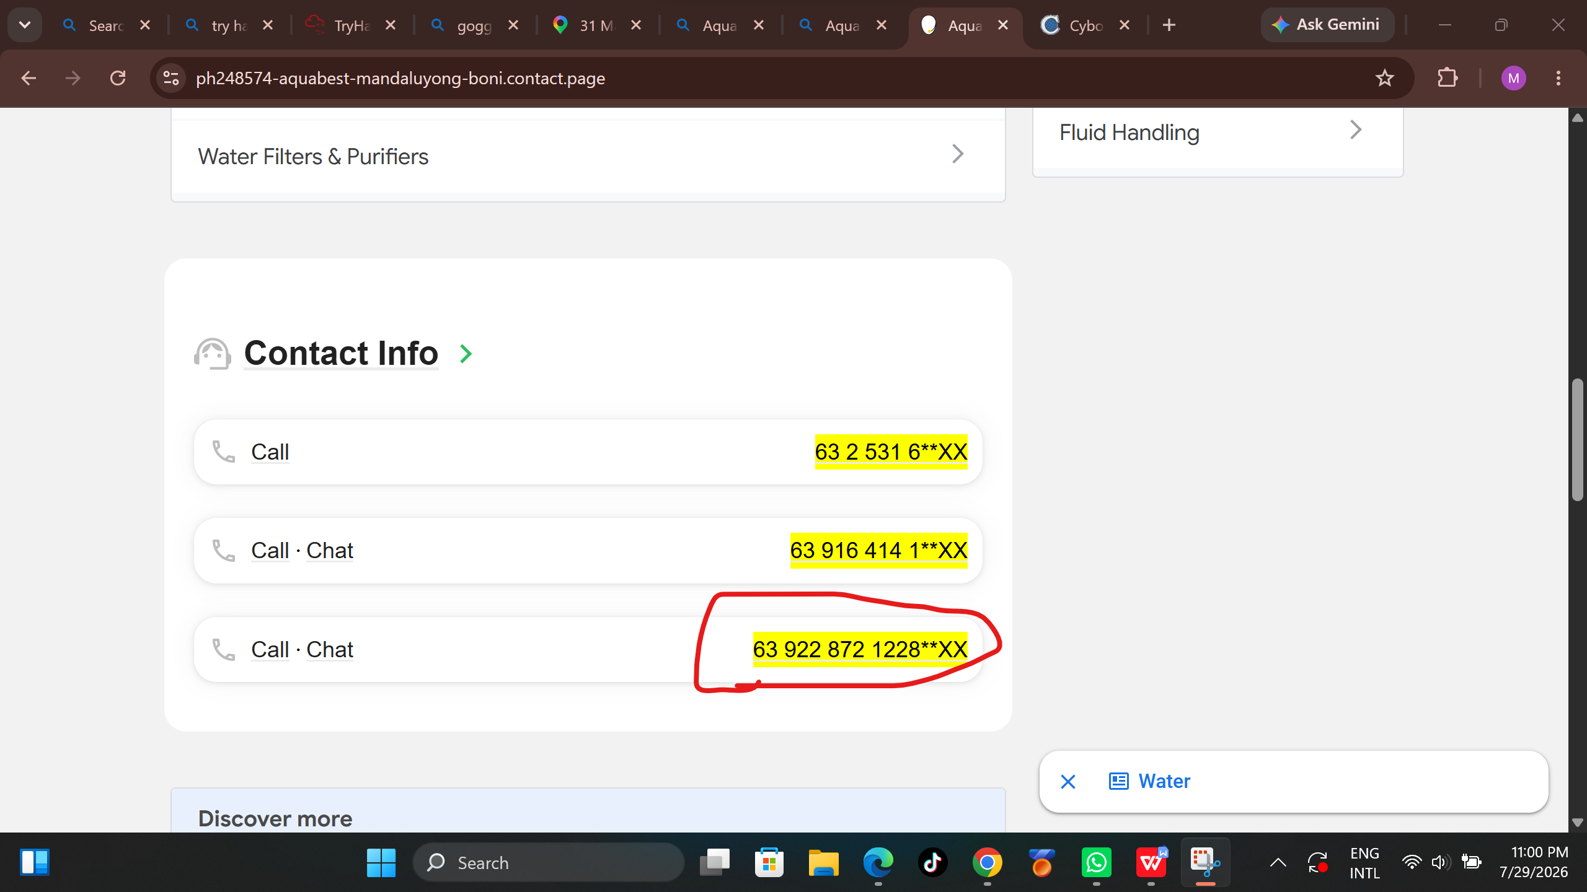
- Then I clicked the number to Reveal the hidden ones.

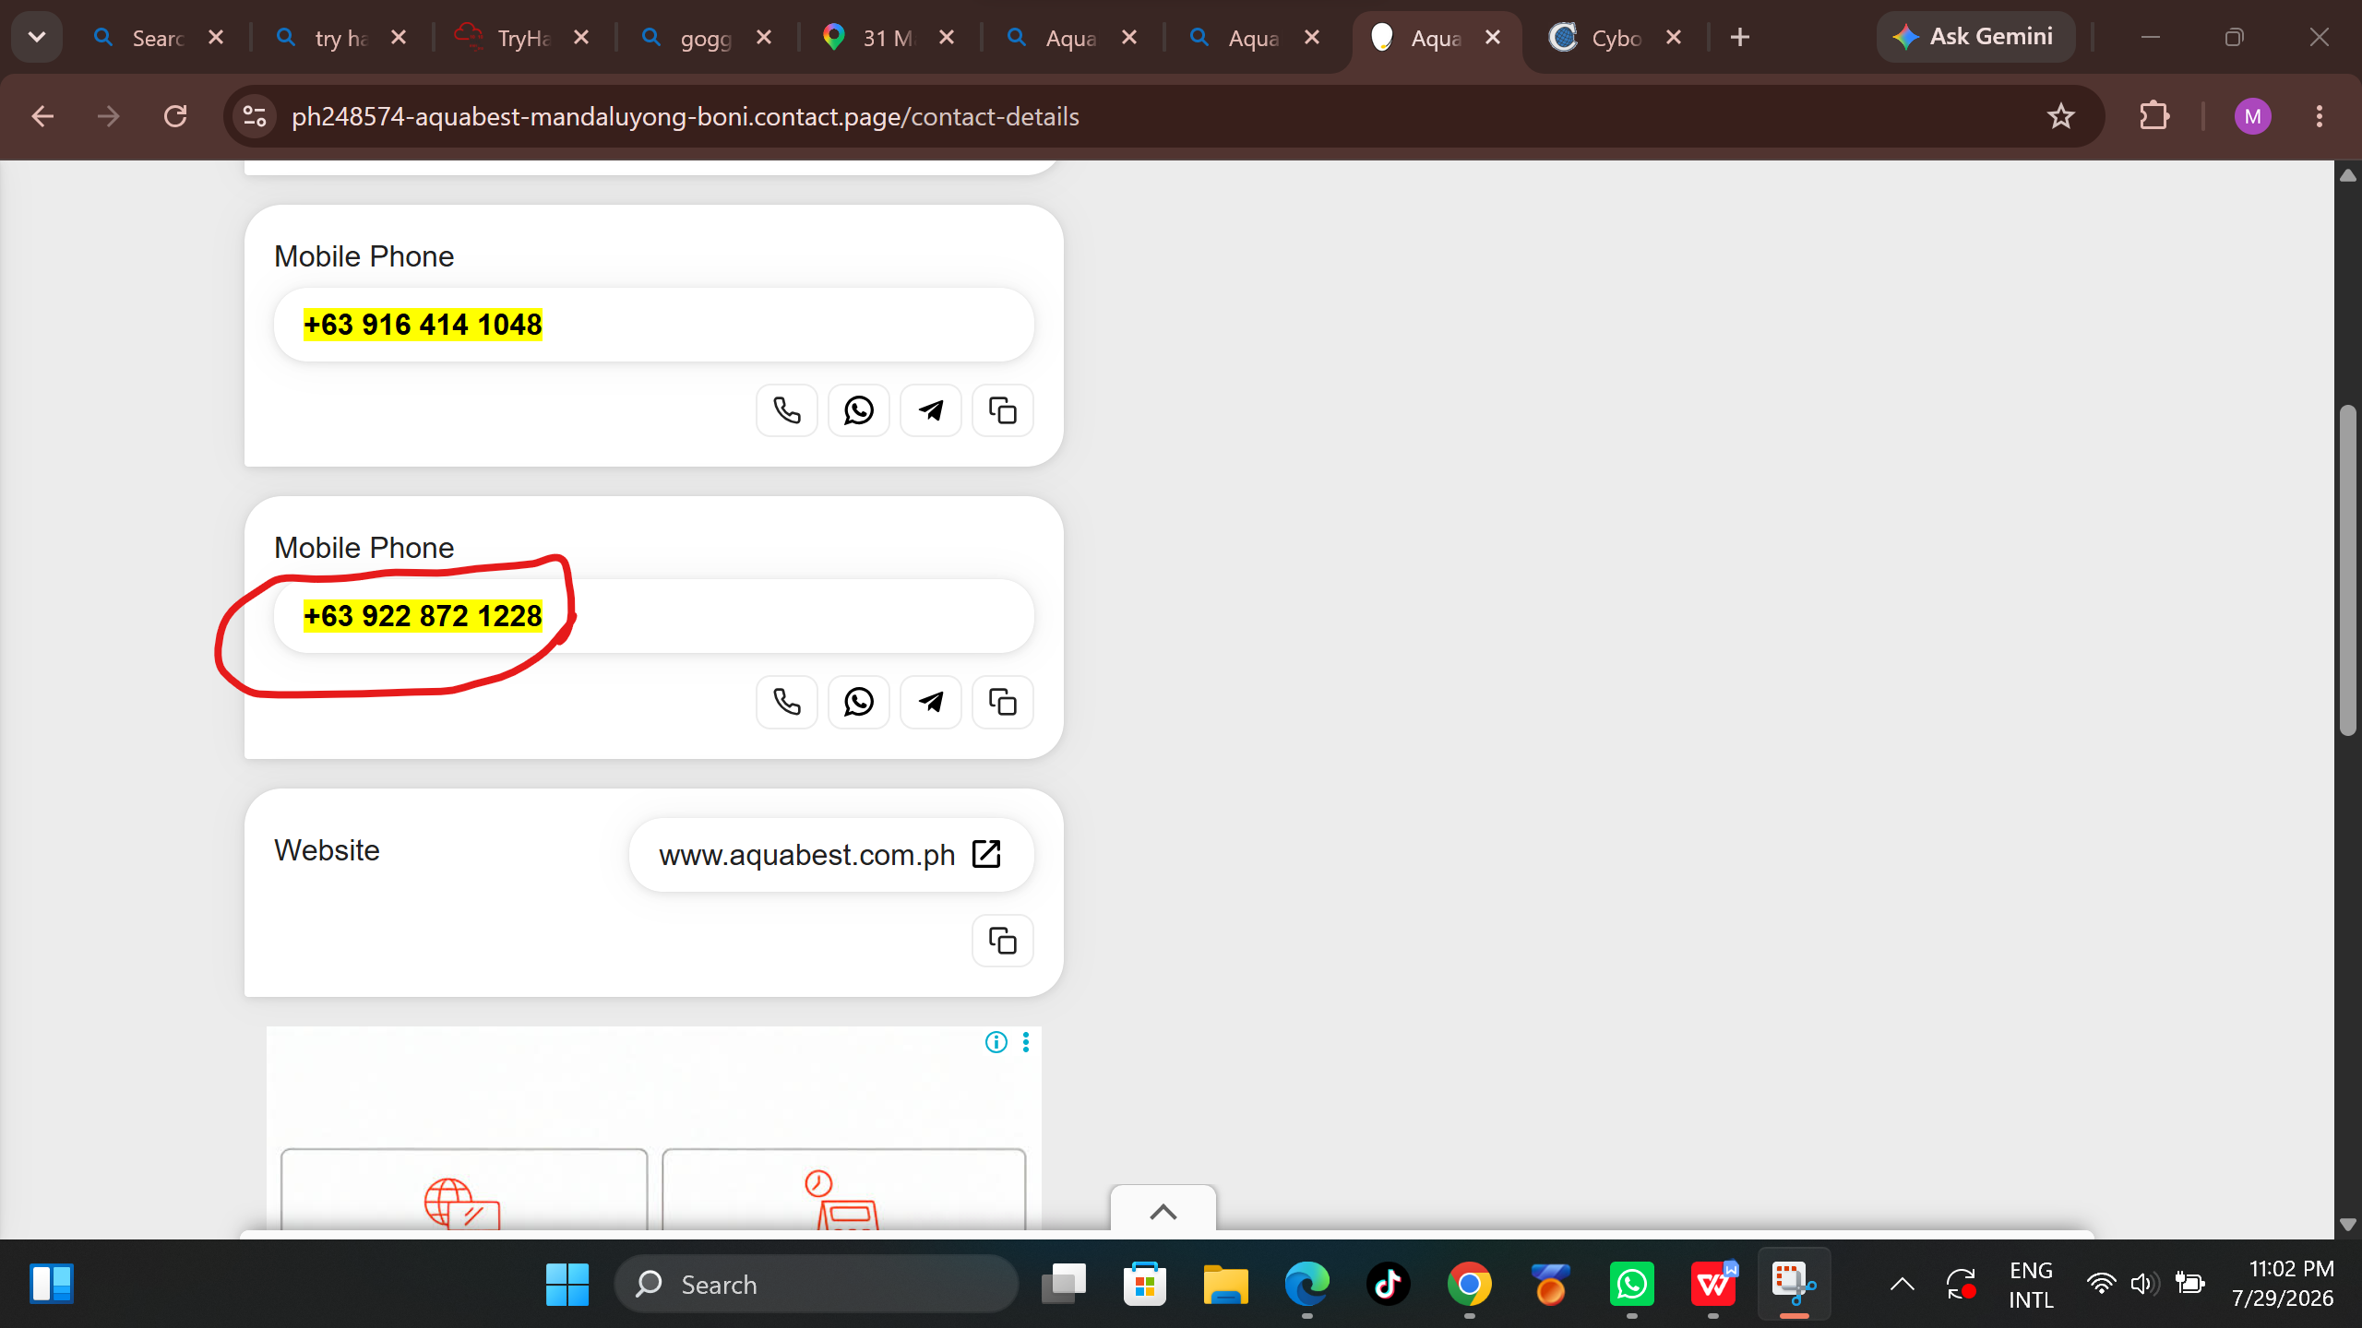
- I then copied the number and inputted it into the challenge answer field with the name of the company to complete it.
